**IFT 266 Introduction to Network Information Communication Technology (ICT)   
  
Lab 25**

**Configure static routes on a VLSM network.**

Co-authored by Jonathan Lima

1. Open the packet tracer file (topology) that you saved from lab 24 (if you did not save the file as instructed, then you will need create the topology in packet tracer).   
     
   If you configured everything correctly in lab 24, the PCs on a single subnet should be able to ping each other, however a PC will not be able to ping a PC on the opposite subnet.   
     
   To give you a glimpse of what you can look forward to in IFT 366, we will set up this connection in this lab.

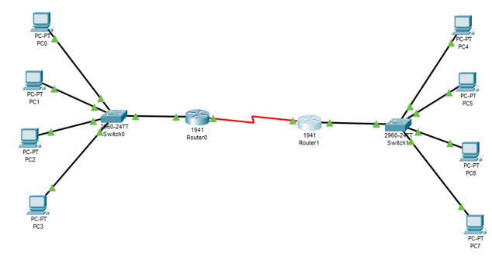



1. On way to create the connection is by creating a static route between the two routers.  
     
   Some things we need to know:

* R0 has an IP address of 172.24.59.9/29 and is on the subnet 172.24.59.8/29.
* R1 has an IP address of 172.24.59.17/29 and is on the subnet 172.24.59.16/29.
* The WAN link between the two routers is on its own subnet, 172.24.59.0/30.
  + The link to R0 is 172.24.59.2
  + The link to R1 is 172.24.59.1.



1. Go into R0’s CLI and enter the following commands:

Router>en

Router#conf t

Enter configuration commands, one per line. End with CNTL/Z.

Router(config)#ip route 172.24.59.16 255.255.255.248 172.24.59.1

Router(config)#exit

Router#

%SYS-5-CONFIG_I: Configured from console by console

The command you just entered is telling the router that if it receives a message addressed to any device on the network 172.24.59.16/29, that it needs to forward it out the port with the address of 172.24.59.1. This establishes a path from R0 to R1.



1. We will enter a similar command on R1, so that it has a path back to R0.

Router(config)#ip route 172.24.59.8 255.255.255.248 172.24.59.2



1. If everything was done correctly, all the PCs should be able to ping each other regardless of which subnet they are on!   
     
   Attached a screenshot of a successful ping from PC0 → PC4 below.